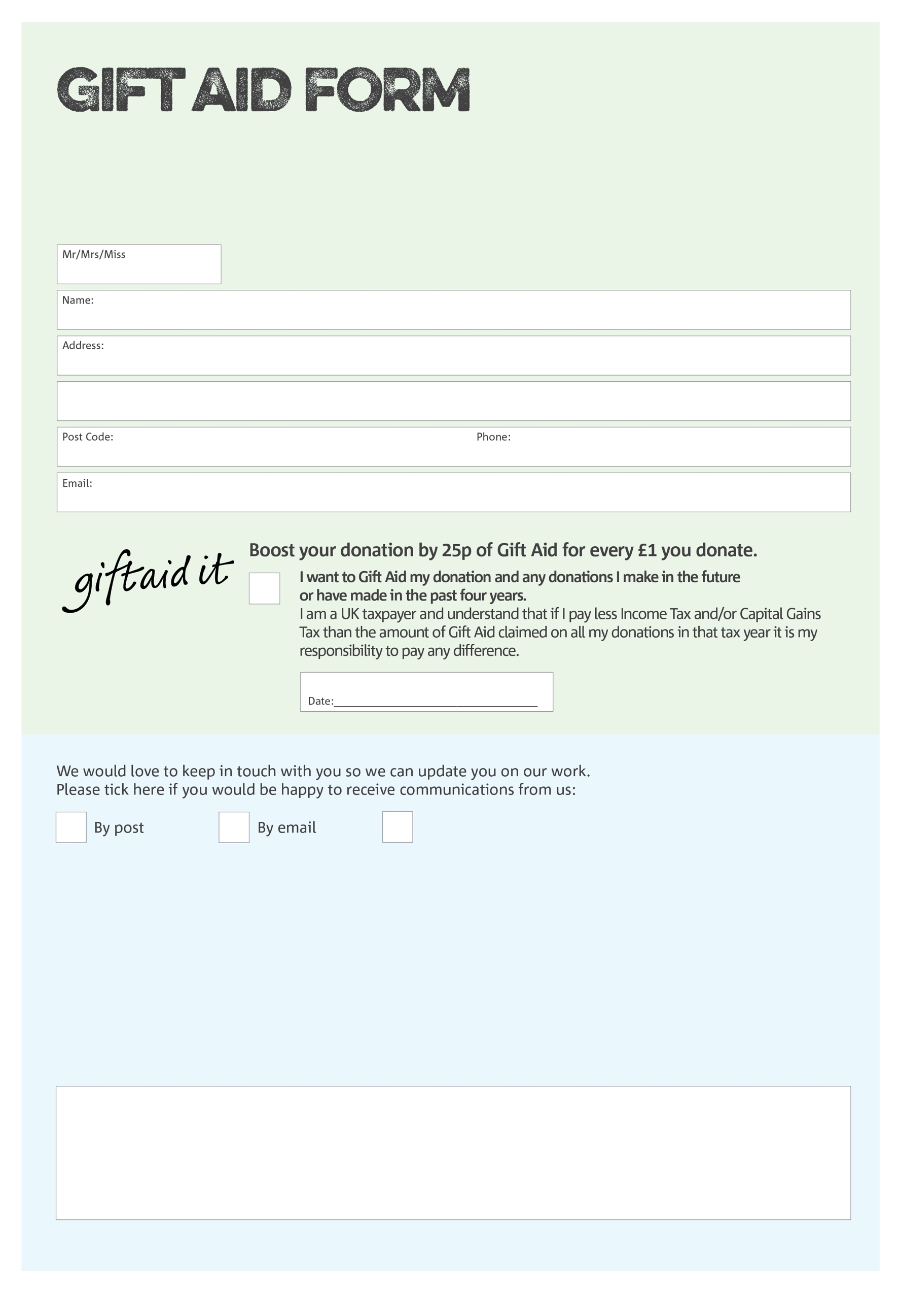

By filling in this form Bracknell Foodbank will receive an extra 25p for every £1 you give at no extra cost to you. Thank you!

**Data protection**

*'Bracknell Foodbank is committed to protecting your privacy and will process your personal data in accordance with current Data Protection legislation. Bracknell Foodbank collects information to keep in touch with you and supply you with information relating to our work. To unsubscribe from our newsletter, send a message to the email address above with the word unsubscribe in the subject line. A full data privacy statement for financial donors is available from the foodbank on request.’*

You can change your preferences any time by contacting us on 01344 862699 or emailing us at

foodbank@kerith.church

I do not wish to receive future communications from Bracknell Foodbank

We would love to know why you have chosen to donate to Bracknell Foodbank. If you would like to share your motivation let us know below:

Charity Number 1124519. Registered in England & Wales